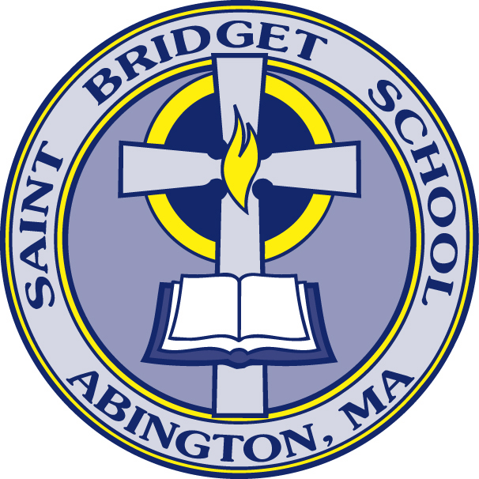
Saint Bridget School
455 Plymouth St.
Abington, MA 02351
781-878-8482 – 781-878-4471 – sbsoffice@stbridgetschool.us
NEASC ACCREDITED

SBS Preschool + Pre-Kindergarten
Tuition 2025 – 2026

Tuition rates subject to change for the 2026-2027 school year.

FLEX DAYS | TUITION
Any 3 HALF DAYS | $6,363.00 per year
Any 3 FULL DAYS | $7,938.00 per year
Any 4 HALF DAYS | $7,497.00 per year
Any 4 FULL DAYS | $9,072.00 per year
5 HALF DAYS | $7,849.00 per year
5 FULL DAYS | $9,424.00 per year

Morning Half Day Session Full Day Session
7:45 A.M. – 11:30 A.M. 7:45 A.M. – 2:10 P.M.

Please note that times may be adjusted slightly as we determine drop off and pick up procedures for the new Early Childhood Center.

The 2025 – 2026 school year billing cycle will begin on July 1st, 2025. Automatic Withdrawal is required for Tuition and Incidental Billing.

SEAT FEE: A $500 non-refundable seat fee per child is required upon enrollment packet submission, and then annually as part of the Continued Enrollment policy. The Seat Fee is applied, in full, to the 2025-2026 tuition.

FUNDRAISING COMMITMENT: Each family is responsible for an annual $600 mandatory fundraising commitment for students in Preschool – Grade 8. Families have the following options:

- Option 1: Families who choose to participate in the fundraiser commit to selling 30 calendars at $20 each, totaling $600. Payment must be submitted along with the raffle stubs or noted to be processed through FACTS incidental billing. Preschool and Pre-K families who do not have older children in the school have a prorated scale, reflective of their number of registered days, for calendar sales.

3 Days (Sell 15 Calendars) or $300.00 fee
4 Days (Sell 25 Calendars) or $500.00 fee
5 Days (Sell 30 Calendars) or $600.00 fee
- Option 2: Opt-Out Option - Families who choose not to participate in the calendar fundraiser will be assessed a $600 fee, or prorated fee, through FACTS incidental billing, which will be posted to FACTS accounts on December 1, 2025.

Assisting prograM: Families have the option to participate in an Assisting Position to receive a tuition credit. This program allows families to contribute their time and skills in exchange for a reduction in tuition costs. If you are interested in applying for an Assisting Position, please contact the School Office for more details on available roles and requirements.

One half of the “full tuition amount” must be paid by December 15th, 2025, for students to be readmitted to the school in January 2026.

