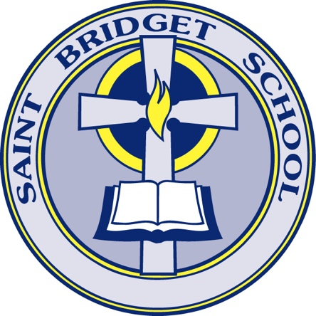
Early Childhood
Registration Requirements

Thank you for expressing your interest in the Saint Bridget School Early Childhood Program, Preschool (3 year olds) and Pre-K (4 year olds). Registrations are not considered complete until we have received all of the following components:

- Completed Online Registration
- Copy of Birth Certificate
- Copy of physical/immunization record from PCP (Current within 1 year)

A student cannot attend the program until all components are received.

**Students need to be fully potty trained and independent in the bathroom. We reserve the right to postpone/rescind acceptance into our program if a child is not independent in the bathroom.

A potty trained child is a child who can do the following:

- Be able to TELL the adult they have to go potty BEFORE they have to go. They must be able to say the words “I have to go potty” BEFORE they have to go.
- Be able to pull down their underwear and pants and get them back up without assistance.
- Be able to wipe themselves after using the toilet.
- Be able to get off the potty by themselves.
- Be able to wash and dry hands.
- Be able to postpone going if they must wait for someone who is in the bathroom or if we are outside for recess.

